Towards Arabic Rendering Issues - MHTML Approach

H. Haddouti¹, A. Maeda², T. Sakaguchi³,
S. Sugimoto³, K. Tabata³
²Nara Institute of Science and Technology, Japan
³University of Library and Information Science, Japan
¹ FORWISS (Bavarian Research Center For Knowledge-based Systems)
Orleansstr. 34, 81667 Munich, Germany
haddouti@forwiss.tu-muenchen.de

Abstract
WWW and Internet have linked all parts of the world and built a platform which we call "digital earth". However, there are still barriers to overcome in order to benefit from those worldwide information resources. Displaying multilingual documents poses a big problem because of specific characteristics of each language and its character sets.
In this paper, we will briefly give a tutorial on several character sets, and then we will discuss rendering issues in Arabic. Finally, we will present our approach, MHTML, which allows displaying multilingual documents without installing required fonts.

Résumé
WWW et l ' Internet ont lié presque toutes les parties du monde et ont construit une plateforme qu´on appelle "le monde numérique ou digitale". Mais, il y a encore des obstacles à surmonter pour pouvoir bénéficier globalement des ressources d´ information. L´affichage des documents multilingues pose un grand problème, parce que chaque écriture ou bien chaque ensemble de caractères présente des caractéristiques spécifiques.
Dans cette contribution, on va donner une introduction brève sur ce qui concerne les caractères, et après on va discuter les problèmes de la logique de rendu des caractères arabes. En fin, on va présenter notre solution, MHTML, qui permet d´afficher des documents multilingues sans avoir besoin d’ installer les polices de caractères exigés.

1. Introduction
Although 6,700 languages are spoken in 228 countries and English is the native language of only 6 % of the World population, English is the dominant language of the collections, resources and services in the Internet. Actually, the English language is widely used on the Internet. About 60 % of the world online population is represented by English, and 30% by European languages [4]. As of March 1999, 159 M people are connected to the Internet (US and Canada about 88 M, Europe 37.15 M, Asia/Pacific 26.97 M, Africa 1.14 M, Middle East 0.88 M). However, the size of Web sites and Internet users from other countries (non-English countries) is increasing progressively, so that the multilingual products will reach soon their high level of importance.
The WWW has been established as widely used platform for information systems. Many companies or in general information provider linked their databases to the Web in order to make their information worldwide accessible and to benefit from the ease-use of Web browsers. However, there is often a problem presenting, for example, a foreign home page written in "foreign" languages and non-Western languages, such as Arabic, Greek, etc. We cannot expect that every user must install fonts for all character sets in order to display documents written in Arabic, Greek, etc. The well-known Web browsers support mainly ISO-8895-1 and several Western language particularities. Some local solutions have been implemented by Web browser provider to meet the national and local needs. However, these browsers are usually limited to a few languages only, e.g. Arabic Web browsers cannot display documents written in Greek.
Nowadays, search engines, such as AltaVista, play a key role in finding information. Search engines will search for what a user types in, sometimes using fuzzy logic for stemming and query expansion. But how can you search for documents written in Arabic if your terminal does not support Arabic input? Think of name giving for organizations, buildings and so on. In most cases, the names are given in the local language. Many online catalogs (e.g. OPAC) are accessible via the Internet, but it is difficult to read records from a foreign terminal, if they are encoded in non-ASCII codes [1].
Some tools and applications are based on the Unicode, which seems to resolve the character set and data exchange problems. However, migrating of legacy data should be loss free and at minimum of costs. Unicode is a single 16-bit which allows encoding of more than 65,000 characters. This means that most known languages in the world are covered by this code. Most operating systems, Microsoft, IBM, DEC, Sun and Apple use Unicode. HTML 4.0 and recent versions support Unicode as the reference character set for Web pages. Alis Technology produced Tango, based on Unicode, which supports all business languages for display and input purposes. The Microsoft Front Page Editor, Java, database systems Oracle, Sybase, and Informix are designed to support Unicode.
The relevant aspects for the internationalization and multilingual text access are character sets, user interfaces and WWW which ensure correct data representation, interpretation, manipulation and presentation. According to these issues, many working groups have been built. For instance, at the W3C Consortium several groups focus on the internationalization of HTML, URL, HTTP [3][7]. Other US and European initiatives look at multilingual information access and metadata. However, these activities are not the subject of this paper, and therefore they will be not discussed.

2. Character Sets
The representation of the information character has been started by IBM with BCD (Binary Coded Decimal) standard of 63 characters. In 1964, this set has been expanded to EBCDIC (Extended Binary Coded Decimal Interchange Code) with a repertoire of 255 characters which include accents, umlauts, and other European and Latin American diacritics. Afterward, the ASCII code showed its efficiency and simplicity, an began to challenge EBCDIC. A conversion between both formats is not suitable, since the ASCII code do not deal with special characters such accents, umlauts etc.
In Europe, Teletext has been defined to develop the character code to meet all European languages requirements. However, it was very difficult to integrate Teletext in the existing computer solutions and finally the attempt failed [5].
Other attempts have also been made in the Middle East and the Far East. The result is that many standards exist, even for one language there were and still are many standards (Microsoft standard, IBM standard, X standards etc.). Local and ad hoc solutions (character code pages, communication protocols, etc.) have been developed. Incompatibility of character set and information exchange were not considered as serious issue. But since the WWW has been invented and widely used, the term “interoperability” becomes crucial.
The ISO 8859 character sets were designed in the mid-1980s by the European Computer Manufacturer's Association (ECMA) and endorsed by the International Standards Organization (ISO). ISO 8859 is a full series of several standardized 8-bit character sets for alphabetic writing languages, see the following table of character sets:

Standards | Description
ISO 8859-1 | Latin1 (West European)
ISO 8859-2 | Latin 2 (East and Central European)
ISO 8859-3 | Latin 3 (South European)
ISO 8859-4 | Latin 4 (North European)
ISO 8859-5 | Latin and Cyrillic (Slavic)
ISO 8859-6 | Latin and Arabic
ISO 8859-7 | Latin and modern Greek
ISO8859-8 | Latin and Hebrew
ISO8859-9 | Latin 5 (Turkish)
ISO8859-10 | Latin 6 (Nordic)
ISO8859-11 | Latin and Thai
ISO8859-12 | Not defined
ISO8859-13 | Latin 7 (Baltic Rim)
ISO8859-14 | Latin 8 (Celtic)
ISO8859-15 | Latin 9 with the symbol “euro”

The first character codes (0-127) of ISO 8859 contain the same character as in ASCII; the codes in the range 128-159 are reserved for control sequences; and the codes between 160 and 255 are reserved for different characters varying from language to another.
The ISO 8859-1 is widely supported in WWW and other operating and application systems as well. However, several applications are based on the Windows code page 1252 (cp 1252). These applications are simply not compatible with those based on ISO 8859-1, because the mapping of character codes to glyphs is different. For example, whereas the code positions 128-159 in ISO 8859-1 are reserved for control functions, the Windows code page 1252 assigns those positions to printable characters, such as the trademark symbol.
ISO 8895 sets allow 8-bit representation. This means that only 256 characters can be represented and processed by their applications. However, 8-bit is not enough for the CJK character (Chinese, Japanese and Korean). Therefore an extension to 16-bit is crucial. As consequence of several activities and discussions, the worldwide character standard, Unicode, has been designed to cover all languages of the world.
The Unicode is the worldwide character standard used for representing and encoding text to support the interchange, processing and presentation of written texts of multiple languages. All Unicode character codes are described by descriptors. Each descriptor is prefixed by “U+” and followed by hexadecimal number which corresponds to the character position in Unicode. For instance, U+0661 is the Unicode character 'ARABIC-INDIC DIGIT ONE' and U+0000 to U+00FF covers the range of Latin-1 character set. The Unicode Standard also includes punctuation marks, diacritics, mathematical symbols, technical symbols, arrows, dingbats, etc.
It is fully compatible with the International Standard ISO/IEC 10646-1. About 65,000 characters can be encoded, which are sufficient for representing the most known character sets of the world including Arabic, Cyrillic, CJK, Latin, Thai, Tibetan, etc. Furthermore, the Unicode Standard and ISO 10646 can be extended to the so-called UTF-16 (Unicode Transfer Format) that allows encoding a million more characters, without use of escape codes.

3. Rendering Issues
Text rendering is the process of assigning characters to glyphs. For some languages, rendering is simple, while others pose a big challenge in displaying text, because of special diacritics, direction, ligatures, and contextual forms. Rendering of characters of such languages needs a complex processing.
The Arabic language has 28 letters which consist of consonants and a few long vowels. The so-called "short" or "light" vowels are placed above and below characters, and their representation is a huge challenge. Generally, short vowels are used in a very few cases, e.g. in the holy Coran, where the exact pronunciation is very important. However, this problem remains unresolved for sophisticated information retrieval systems. Hence, the question arises, how to represent such vowels. To represent each vocalized character as single code is not efficient, because we will need a very large repertoire of codes. Additionally, it is sometimes desirable to display such text with or without vowels.
Hence, vocalization (or diacritics) in Arabic poses a big issue in character rendering and in retrieval as well. Other issues are that most operating systems do not support Arabic character code sets, keyboard mapping, date and time format, etc. Existing of some ligatures poses further problems. For instance, the LAM-ALEF ligature is mandatory. Moreover, Arabic is a cursive language, i.e. characters are linked together. Rules exist to define how to link characters, but the font still need to be adapted to this form.
An Arabic character might take on four different glyphs depending on its position in the word, i.e. at beginning, in the middle, surrounded and standalone. Some characters present only one or two glyphs. Another aspect is the bi-directional direction of writing. Arabic text is written from right to left, while Arabic digits and Latin characters are shaped from left to right.
Arabic characters are stored in logical order different from the visual order. The logical order corresponds to the reading/typing order. This means that the internal storing structure, which is based on ISO or other standards codes, does not correspond to the visual structure which depends on the contextual form of the Arabic language. The conversion from the logical into visual order is the main issue in rendering Arabic. The cut&paste and mouse selection can be not straightforward implemented. Extensive processing is obligatory.
In Arabic, there are often the problem that documents written in one system (e.g. Macintosh) can be not displayed on some browsers, because of the existence of a number of different code pages. That means, an Arabic glyph or letter has different character code among those various code pages. This is one of the biggest issue of developing Arabic application that can be used worldwide, such as an Arabic browser. Many publishers, like news agencies, still provide their information as images via WWW, because no real software can help them publishing and displaying their information resources correctly and properly. This solution leads to user frustration because of slow download and search inability.

4. MHTML Approach
MHTML, developed at the University of Library and Information Science (ULIS) in Tsukuba Japan, aims at presenting multilingual documents, even if a browser and a client platform do not contain and support the required fonts. This system has been extended to allow the input in multiple languages. Using MHTML server, users can display multilingual documents from any Java-enabled browser [2], see Figure 1.
The MHTML system consists of two components, MHTML server and MHTML viewer applet. The MHTML server converts on the fly an HTML document into an MHTML document and sends it to a client. Once the viewer applet receives the MHTML document, it will display this document on the client browser. Both components are described in more detail in the following:
Multilingual-HTML (MHTML) server is a WWW gateway between a Web client and a Web document server which converts a source HTML text into an object called MHTML object, which includes the source text string and a minimum set of font glyphs. The server sends the MHTML object and an MHTML browser applet, called applet viewer, to a client. The MHTML browser applet displays the source text on the client using the glyphs included in the object.
The MHTML applet viewer is a Java applet which allows displaying HTML pages written in various languages, without the installation of any fonts. The use of this applet allows to display multilingual documents easily on WWW.
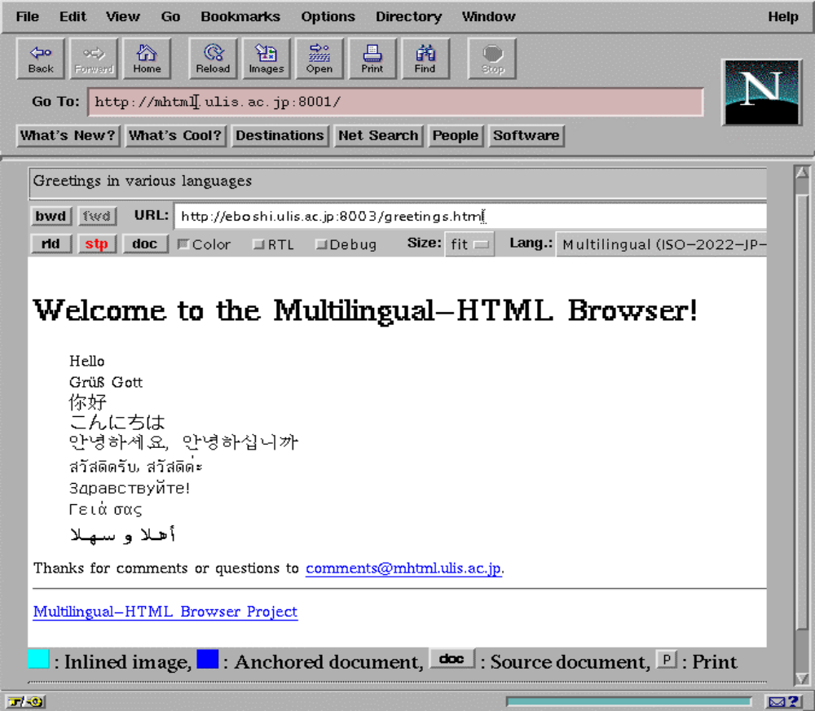
Figure 1: MHTML Web Browser

Recently, the MHTML solution has been extended to an Input function for “foreign” texts [6]. A text input function is a mapping from a key input sequence to a character code or to a character code string. The mapping function can be located in a remote server as well as the MHTML server which makes a character code string in a foreign language visible to the user.
The text input function will provide a user with the ability to search in multilingual documents, even if their computers do not include or support corresponding input systems. The user submit his/her query in transliterated Japanese which will be converted to the Japanese characters. The converted terms are presented to the user in order to be verified (feedback). Finally, the selected terms will be sent to search engines to retrieve a collection. This function is first tested for Japanese and it is planned to be expanded to other languages.
MHTML has been installed in ULIS and in Virginia Tech Library and has been used to view an electronic collection of folktales in multiple languages. MHTML is now restricted to CJK character set, western languages, Cyrillic, Greek, Turkish and Thai. An extension of MHTML to Arabic is underway and the first tests are in operation.

5. Conclusion
In this paper, we have briefly given a survey about several character sets and we faced the issues that occur while rendering the Arabic characters. As an innovative solution, we described our MHTML approach. However, there are still a lot of work to do in this area. In our view, the major important starting point is to build an human network working on this subject in order to coordinate our activities and to avoid redundancy.
Concerning MHTML, it is worth to extend the input functionality to Arabic by providing a virtual keyboard as Java applet. This will help users around the world to search in Arabic, even if they do not have engraved Arabic keyboards. Hence, methods and algorithms for the morphological analysis are needed.
In General, large Arabic or bilingual corpora and testbeds in electronic form are necessary for evaluating Arabic computing systems. For instance, extending semantic lexicons, such as WordNet and EuroWordNet, is of great importance. Standardization is very crucial especially for character sets and dynamic information resources. Such standards must be comprehensive and based on well referenced models and clear definitions by involving all parties.

Acknowledgments
We would like to thank Prof. Shunsuke Uemura of Nara Institute of Science and Technology for his generosity in letting Mr. Maeda spends time in MHTML development.

References

H. Haddouti. Multilinguality Issues in Digital Libraries. Proceedings of the EuroMed Net'98 Conference Nicosia, March 3-7, 1998
A. Maeda, et al. Viewing Multilingual Documents on Your Local Web Browser, Communications of the ACM, 41(4): 64-65, April 1998
G.T. Nicol. The Multilingual World Wide Web, Electronic Book Technologies, Tokyo, 1995
NUA, Internet Consultancy and Developer, October 1998 (http://www.nua.net)
G. Sadowsky. Language, Alphabets, and the Multilingual Internet. In Connect, Summer Edition 1998 http://www.nyu.edu/acf/pubs/connect/summer98/DirMultiSum98.html
S. Sugimoto et al. Experimental Studies on an Applet-Based Document Viewer for Multilingual WWW Documents - Functional Extension of and lessons Learned from Multilingual HTML. In Lecture Notes in Computer science, SN 1513. Ed. C. Nikolau, C. Stephanidis, ECDL´98, Crete 1998
F.Yergeau et al. Internationalization of the Hypertext Markup Language, RFC 2070, Network Working Group, January 1997 (http://www.w3.org/International/francois.yergeau.html)

http://www.w3c.org
The encoding table of each set can be found at http://czyborra.com/charsets/iso8859.html
http://www.unicode.org
http://mhtml.ulis.ac.jp

